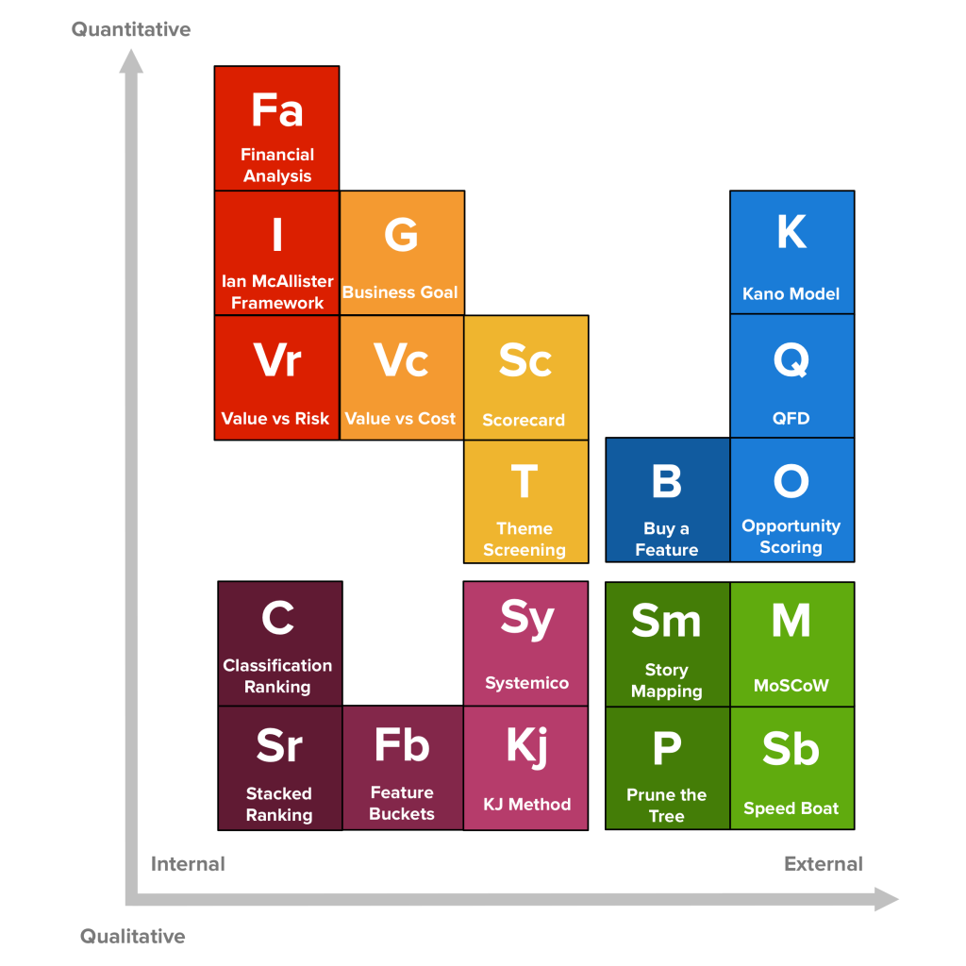

#### **Story Mapping**

The main idea behind Story Maps is that single-list product backlogs are a terrible way to organize and prioritize the work that needs to be done. A richer structure is necessary.

In very broad strokes, a Story Map is organized like this:

* There’s a horizontal axis that represents **usage sequence**;
  + User stories (or “tasks”) are placed along this axis, in the sequence in which they are performed by the user;
* The vertical axis stands for **criticality**;
  + User stories (or “tasks”) are arranged vertically as to how important they are (from top to bottom);
  + Equally important stories can be kept at the same height, but keep in mind that, in general, it’s important to differentiate stories’ relative importance to be able to create better release plans.
* Groups of related user stories can be grouped as *Activities*:
  + Create a vertical line to separate groups of stories from others;
  + For example, an activity may be “managing email”, with “send an email to one or more addresses” being a user task;
  + Activities sit above the vertical axis and don’t have any usage sequence, they “just are” — these activities compose the major attributes for the product and can’t be prioritized (think “you can’t prioritize a car’s motor over its wheels”)

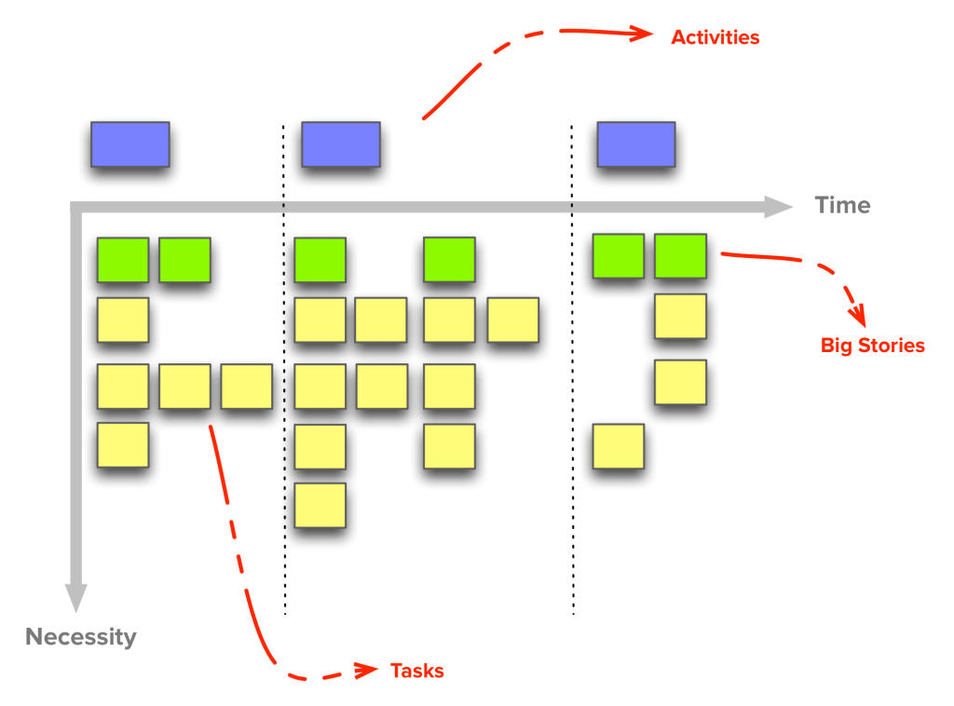

#### **Value vs. Risk**

Features are scored in two dimensions: Value and Risk. There are no prescribed ways to estimate value, and for that you may use one of the other techniques presented here. As to Risk, there are multiple kinds, but we’re usually concerned with:

* **Schedule risk** (e.g. “this might not be done by the time we need it”)
* **Cost risk** (e.g. “this might cost more to run than what the business case allows”)
* **Functionality risk** (e.g. “we might not be able to do this”)

There’s a constant struggle between high-risk and high-value. What should be done first? On one hand, if you avoid risky items and go for high-value first, you might develop a large part of the product before hitting a major roadblock. On the other, if you focus on working on high-risk items first, you might end up doing unnecessary work on features that turned out to be less valuable.

The goal is to look for a balanced approach, going for High-risk/High-value first, Low-risk/High-value second and finally Low-risk/Low-value. High-risk/Low-value items are best avoided.

[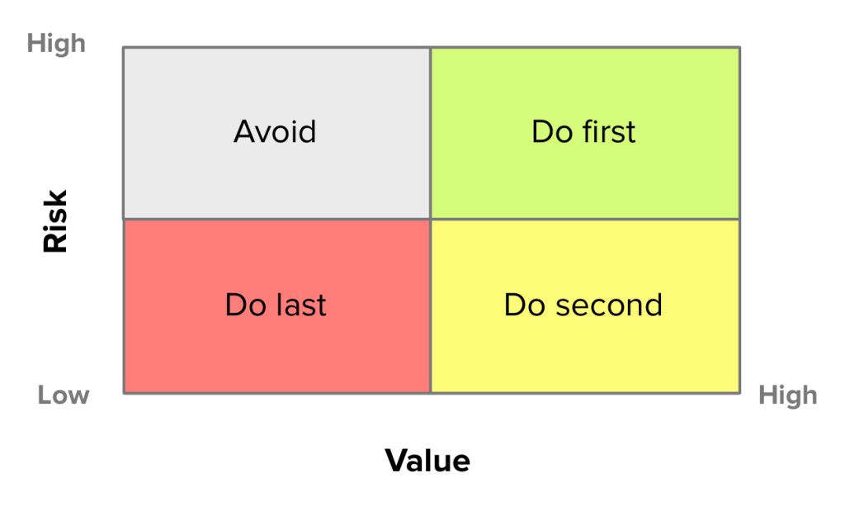](http://foldingburritos.com/wp-content/uploads/2015/11/value-vs-risk.png)

#### **Systemico Model**

The [Systemico model](http://barryoreilly.com/2012/08/21/the-systemico-model/) aims to provide a framework to prioritize entirely in terms of Value to the customer and view that process as something that is systemic and holistic (hence the name.)

Product requirements are made visible in terms of how they address user goals and engagement levels.

The team behind this model has found it to be of particular usefulness “when working on new products and domains that need to be customer and/or user-centric, especially when there is little or unknown validated learning.”

This model is related to Story Mapping, as it also creates a two-dimensional grid that makes it easy to visualize the scope of the product and the different priority levels.

* **User Goals** — The first dimension is User Goals. The product is defined not in terms of What it does but in terms Why some functionality is necessary.
* **User Engagement** — The second dimension uses user engagement as a measure of the interaction level between the user and the product. There are four degrees (in decreasing urgency):
  + **Core**: Features to satisfy users’ basic needs. These are baseline expectations for users in this product space;
  + **Use**: New and improved features to increase the product’s usability. Without these, the product has minimal appeal to the user;
  + **Engage**: Functionality drawing the user to have more interaction with the product and entices her to come back in the future;
  + **Explore**: Features that build a stronger connection between the user and the product as they promote going beyond simple interactions.

User Stories are then placed within the corresponding User Goal and Engagement levels. As User Stories themselves may carry additional value and cost attributes, this model turns into an easy to explore multi-dimensional system.

[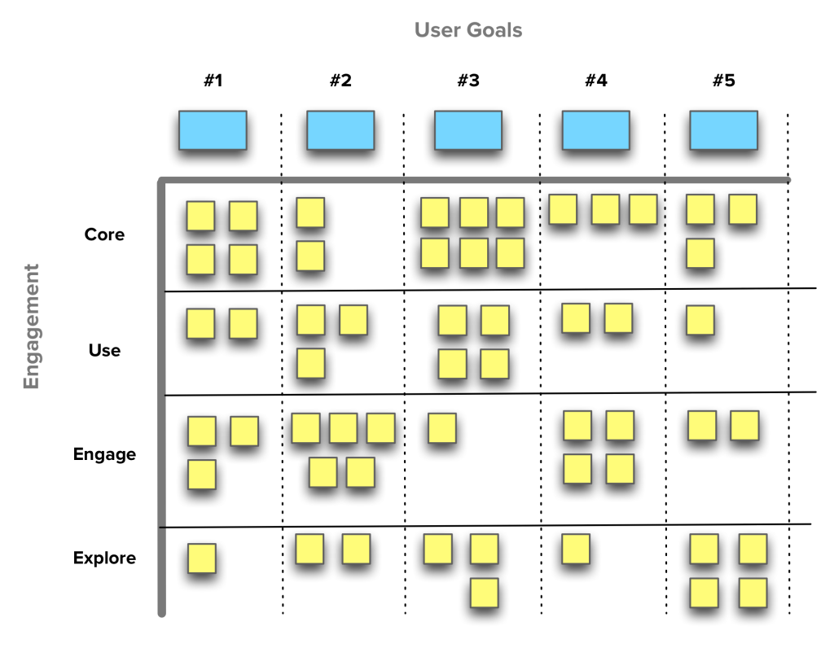](http://foldingburritos.com/wp-content/uploads/2015/11/systemico.png)

EXAMPLE SYSTEMICO BOARD